Documentation

for Android Development Fundamentals

course project

Application: "PosTED"

**

Developed by:

Todor Ilchev

Elica Tasheva

Dimana Toteva

Evaluated by:

Dimitar Ivanov

Sofia – 2016

**1. Description:**

Our project is a mobile place of sale application, mainly for laptops and coming soon - smart phones. It uses a SQLite local database and Kinvey based remote one.

Here is a screenshot describing the functionality supported for the app admin:

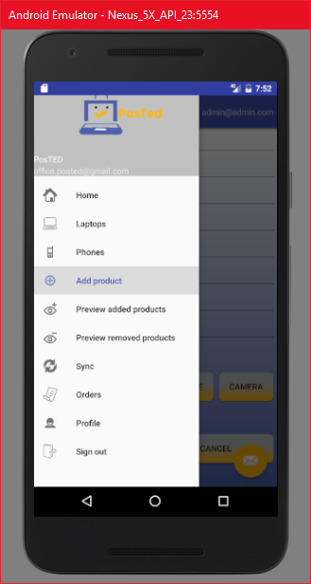

And one for the typical user:

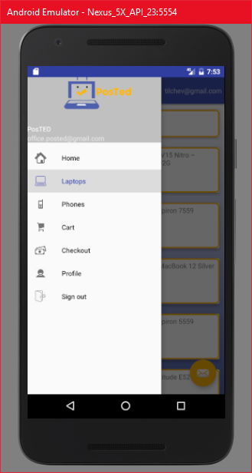

Future plans also include gentrification of the objects to be sold, peer to peer selling (as opposed to the current adding of products only by the app administrator) and filtering of products.